PowerBI Dashboard Design and Development for Healthcare Management System

**Name**: Mahim Sharma

**Subject**: Data Architecture and PowerBI Dashboard Design

**Mentor**: Dr. Junaid Qazi

Table of contents:

**Table of Contents........................................................................................................ 2**

**Intrduction...................................................................................................................3**

**Objectives....................................................................................................................3**

**Key Questions .............................................................................................................4**

**Key Performance Indicators (KPIs)……………..............................................................................................................5**

**Healthcare PowerBI Dashboard..................................................................................................................6,7,8**

**Conclusion................................................................................................................... 8**

**Introduction**

In today's fast-paced healthcare environment, efficient management of hospitals and clinics is crucial. A Healthcare Management System (HMS) serves as a comprehensive platform designed to streamline operations by organizing and tracking essential tasks. By maintaining patient records, monitoring bed occupancy, assessing treatment wait times, analyzing revenue by age groups, and evaluating key performance indicators (KPIs), the HMS enables healthcare facilities to function more smoothly.

This article discusses the objectives of creating a healthcare management dashboard and outlines the five key performance indicators that can significantly enhance decision-making within healthcare management teams.

**Objectives of the Healthcare Management Dashboard**

The primary goal of the healthcare management dashboard is to provide healthcare management teams with an intuitive tool to easily track and understand vital metrics related to patient visits, hospital occupancy, and revenue generation. By visualizing this data, hospital administrators can make informed decisions that lead to improved patient care and optimized resource utilization.

Key aspects of the dashboard include:

* **Patient Visits:** Tracking the total number of patients currently in the hospital.
* **Bed Occupancy:** Monitoring how many beds are occupied versus those that remain vacant.
* **Revenue Analysis:** Examining average revenue and the length of patient stays, categorized by various hospital departments.
* **Resource Management:** Ensuring that investments align with patient demographics and service demand.

For the dashboard to be effective, it is essential to gather data from at least one year of past operations. This historical data allows management to analyse trends and make strategic decisions based on comprehensive insights.

**Key Questions**

1. How many beds are currently occupied?

The gauge chart displays the number of occupied beds in a hospital, showing that 1,751 beds are currently in use out of a total of 3,502. The blue section represents the occupied beds, while the white section indicates the available ones. This visualization provides a quick overview of bed usage and effectively tracks hospital capacity, making it easy to monitor resource availability in real-time.



2. What is the average Lenth of Stay by Age Group of the patient?

This chart illustrates the length of stay for patients across various age groups. Patients aged 60 and older have the longest average stay at 2.0 days, while those aged 21 to 40 have the shortest average stay at 1.46 days. The chart clearly shows a downward trend in length of stay as age decreases, indicating that younger patients typically spend less time in the hospital. This trend highlights how age affects the duration of hospital stays.



3. What is the Total Number of Revenues Generated Monthly?

Hospitals need to gather financial data from all departments, including patient services and diagnostics. This data should be organized by revenue source, such as patient payments and insurance claims. By adding up the revenue from each source, hospitals can calculate the total monthly revenue. Utilizing financial software can simplify this process and enhance the accuracy of tracking overall performance.



**Key Performance Indicators (KPIs)**

The effectiveness of the healthcare management dashboard is largely determined by the selection of relevant KPIs. Here are five critical KPIs that should be included:

1. **Average Patient Wait Time:** This KPI measures the average duration patients wait before receiving treatment. A shorter wait time indicates that the hospital operates efficiently, ensuring that patients receive timely care. Monitoring this KPI helps identify areas for improvement, leading to better patient satisfaction and outcomes.
2. **Bed Occupancy Rate:** The bed occupancy rate reflects the proportion of hospital beds in use compared to the total available. For instance, if a hospital has 100 beds and 80 are occupied, the occupancy rate stands at 80%. This metric is essential for resource management; a high occupancy rate indicates that the hospital is busy, while an excessively high rate may signal overcapacity, straining resources. Conversely, a low occupancy rate suggests that the hospital may not be fully utilized.
3. **Average Length of Stay:** This KPI tracks how long patients typically remain in the hospital. Understanding the average length of stay helps in evaluating patient flow and resource allocation. It can also inform staffing needs and patient discharge planning.
4. **Monthly Revenue by Age Group:** Analysing revenue generation based on age demographics allows hospitals to identify which age groups contribute most to their revenue. This insight can help management target specific age groups for tailored services and marketing, ultimately enhancing profitability.
5. **Total Revenue Generated Monthly:** This KPI provides a snapshot of the hospital's financial health by tracking total revenue generated each month. Monitoring this metric enables management to assess overall performance and identify trends over time.

**Healthcare Power BI Dashboard**

The healthcare management dashboard is designed to improve how healthcare facilities operate by keeping track of important performance indicators (KPIs). Its main goal is to provide insights into areas like patient visits, bed occupancy rates, revenue by age group, and the average length of stay for patients. The dashboard features visual elements, such as gauge charts showing how many beds are occupied and graphs displaying the average length of stay by age group. This helps healthcare management teams make informed decisions. By monitoring total monthly revenue and breaking it down by age demographics, the dashboard becomes a vital tool for managing resources better and enhancing the financial performance of hospitals.

Fig 1: Picture shows PowerBI Dashboard for the Healthcare Management System.

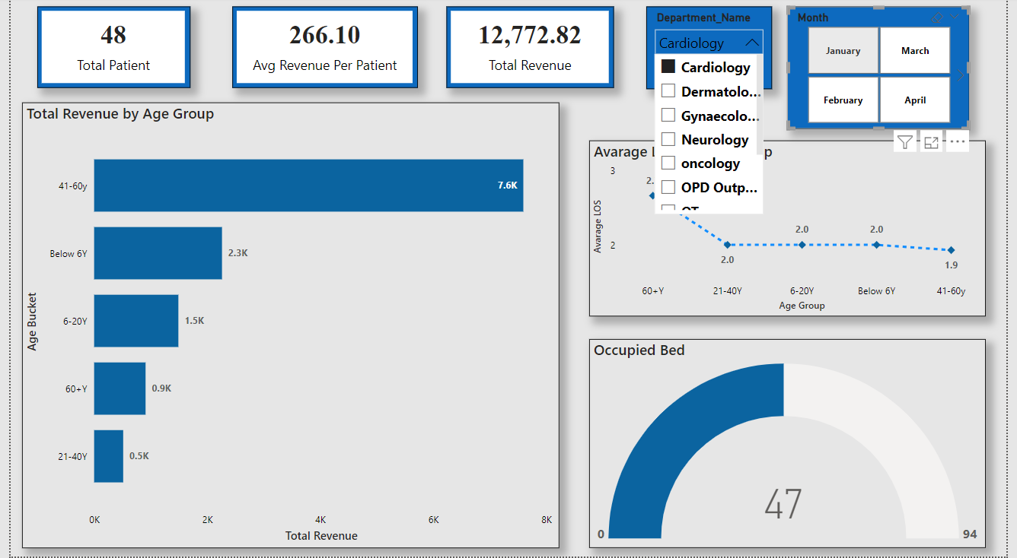

Fig 2: Picture shows PowerBI Dashboard for the Healthcare Management System with the selected Department_Name and show the all the details regarding department.

Fig 3: Picture shows PowerBI Dashboard for the Healthcare Management System to select the month and show the total revenue by age group monthly.

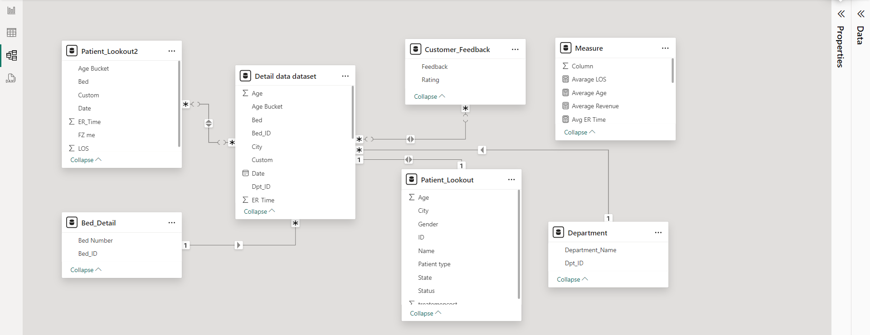

**Conclusion**

In conclusion, developing a healthcare management dashboard is vital for improving the understanding of a hospital's current bed availability, average length of stay, and revenue by age groups. By analysing the data presented through this dashboard, hospital management can make informed decisions regarding patient intake and identify strategies for revenue growth targeting specific age demographics.

Ultimately, a well-designed healthcare management dashboard empowers healthcare providers to optimize their resources, enhance patient care, and navigate the complexities of the healthcare industry effectively.